
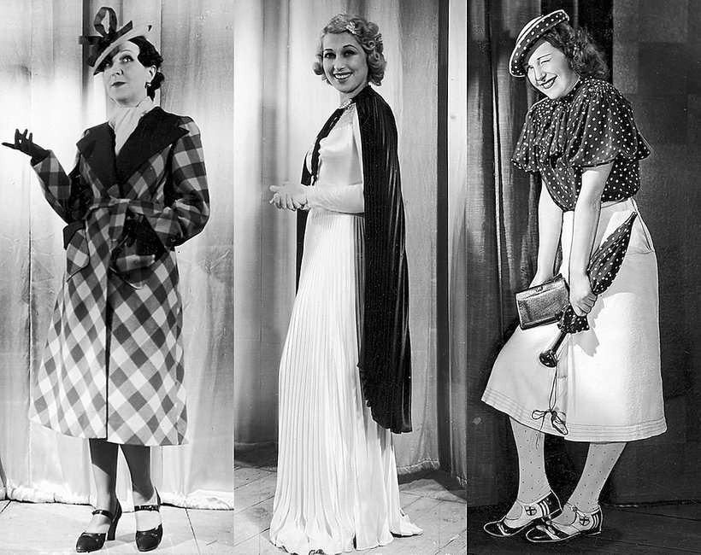
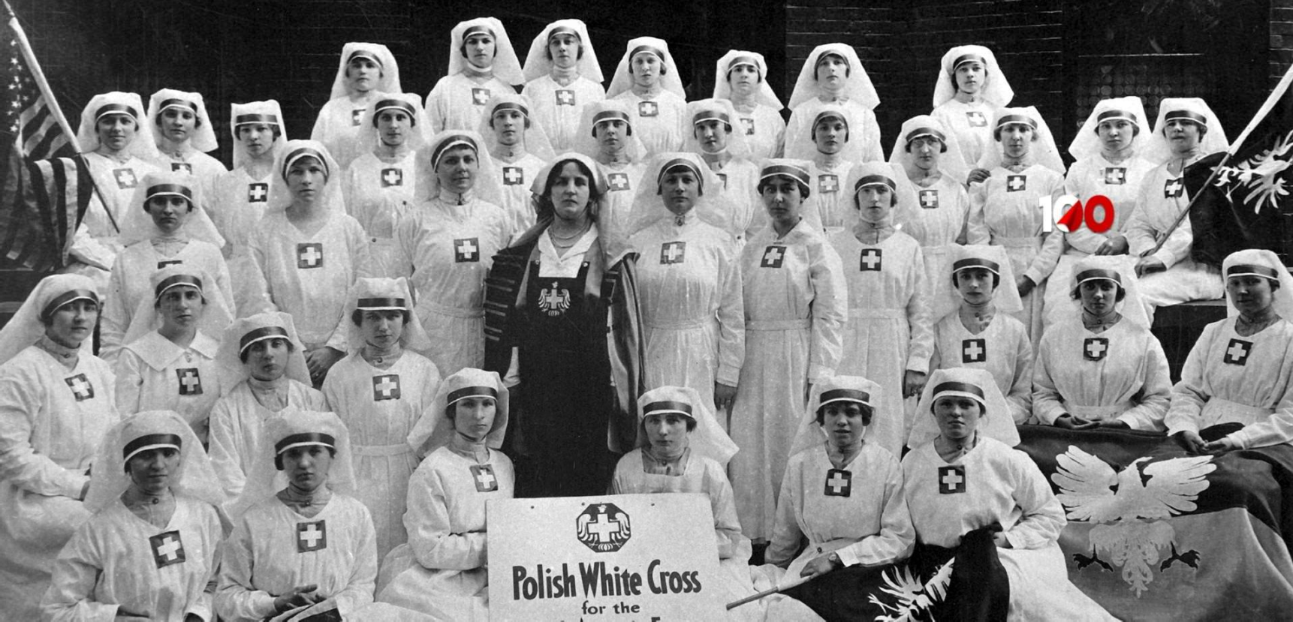
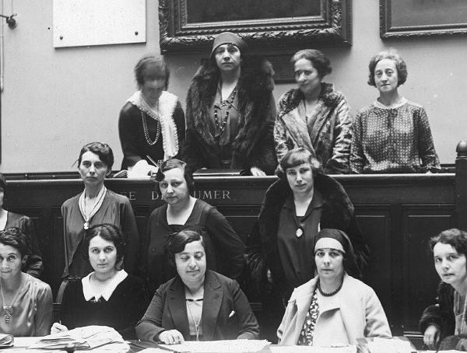
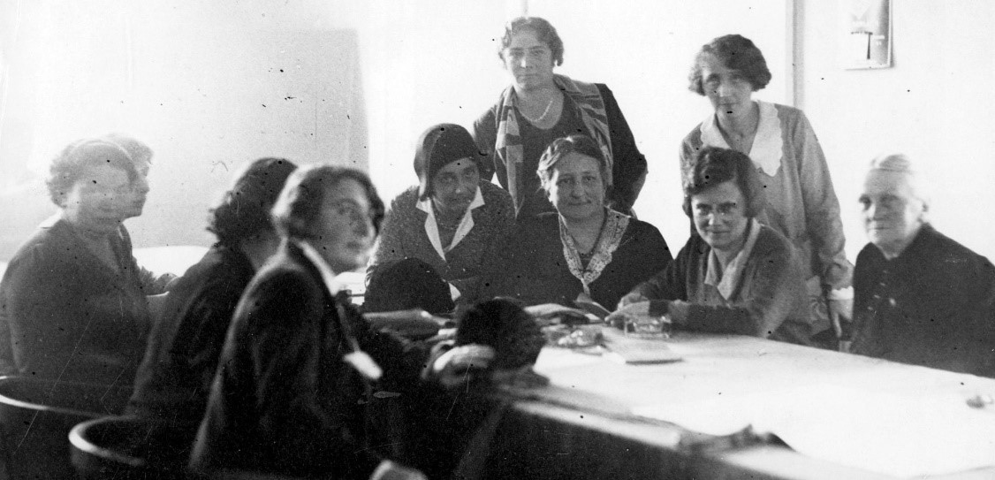
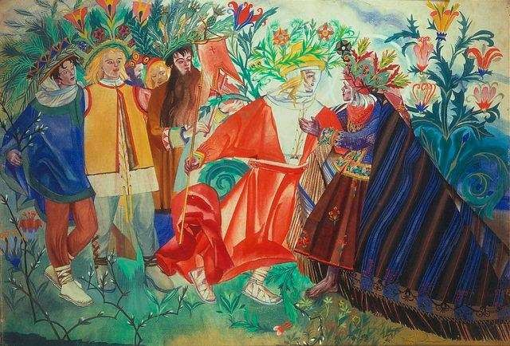
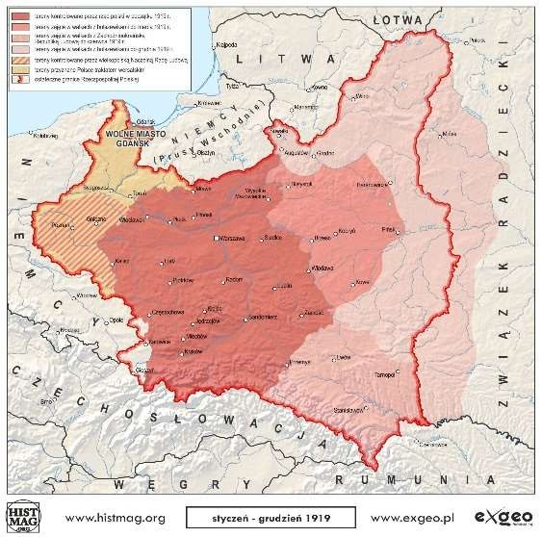Kalendarz Niepodległości

Styczeń
1 | 2 | 3 | 4 | 5 | 6 | 7
8 | 9 | 10 | 11 | 12 | 13 | 14
15 | 16 | 17 | 18 | 19 | 20 | 21
22 | 23 | 24 | 25 | 26 | 27 | 28
29 | 30 | 31
Luty
1 | 2 | 3 | 4 | 5 | 6 | 7
8 | 9 | 10 | 11 | 12 | 13 | 14
15 | 16 | 17 | 18 | 19 | 20 | 21
22 | 23 | 24 | 25 | 26 | 27 | 28
29
Marzec
1 | 2 | 3 | 4 | 5 | 6 | 7
8 | 9 | 10 | 11 | 12 | 13 | 14
15 | 16 | 17 | 18 | 19 | 20 | 21
22 | 23 | 24 | 25 | 26 | 27 | 28
29 | 30 | 31
Kwiecień
1 | 2 | 3 | 4 | 5 | 6 | 7
8 | 9 | 10 | 11 | 12 | 13 | 14
15 | 16 | 17 | 18 | 19 | 20 | 21
22 | 23 | 24 | 25 | 26 | 27 | 28
29 | 30
Mai
1 | 2 | 3 | 4 | 5 | 6 | 7
8 | 9 | 10 | 11 | 12 | 13 | 14
15 | 16 | 17 | 18 | 19 | 20 | 21
22 | 23 | 24 | 25 | 26 | 27 | 28
29 | 30 | 31
Czerwiec
1 | 2 | 3 | 4 | 5 | 6 | 7
8 | 9 | 10 | 11 | 12 | 13 | 14
15 | 16 | 17 | 18 | 19 | 20 | 21
22 | 23 | 24 | 25 | 26 | 27 | 28
29 | 30
Lipiec
1 | 2 | 3 | 4 | 5 | 6 | 7
8 | 9 | 10 | 11 | 12 | 13 | 14
15 | 16 | 17 | 18 | 19 | 20 | 21
22 | 23 | 24 | 25 | 26 | 27 | 28
29 | 30 | 31
Sierpień
1 | 2 | 3 | 4 | 5 | 6 | 7
8 | 9 | 10 | 11 | 12 | 13 | 14
15 | 16 | 17 | 18 | 19 | 20 | 21
22 | 23 | 24 | 25 | 26 | 27 | 28
29 | 30 | 31
Wrzesień
1 | 2 | 3 | 4 | 5 | 6 | 7
8 | 9 | 10 | 11 | 12 | 13 | 14
15 | 16 | 17 | 18 | 19 | 20 | 21
22 | 23 | 24 | 25 | 26 | 27 | 28
29 | 30
Październik
1 | 2 | 3 | 4 | 5 | 6 | 7
8 | 9 | 10 | 11 | 12 | 13 | 14
15 | 16 | 17 | 18 | 19 | 20 | 21
22 | 23 | 24 | 25 | 26 | 27 | 28
29 | 30 | 31
Listopad
1 | 2 | 3 | 4 | 5 | 6 | 7
8 | 9 | 10 | 11 | 12 | 13 | 14
15 | 16 | 17 | 18 | 19 | 20 | 21
22 | 23 | 24 | 25 | 26 | 27 | 28
29 | 30
Grudzień
1 | 2 | 3 | 4 | 5 | 6 | 7
8 | 9 | 10 | 11 | 12 | 13 | 14
15 | 16 | 17 | 18 | 19 | 20 | 21
22 | 23 | 24 | 25 | 26 | 27 | 28
29 | 30 | 31

Autor: Vanessa Motyl, klasa VIII, Szkoła Polska przy Konsulacie Generalnym RP w Hamburgu

